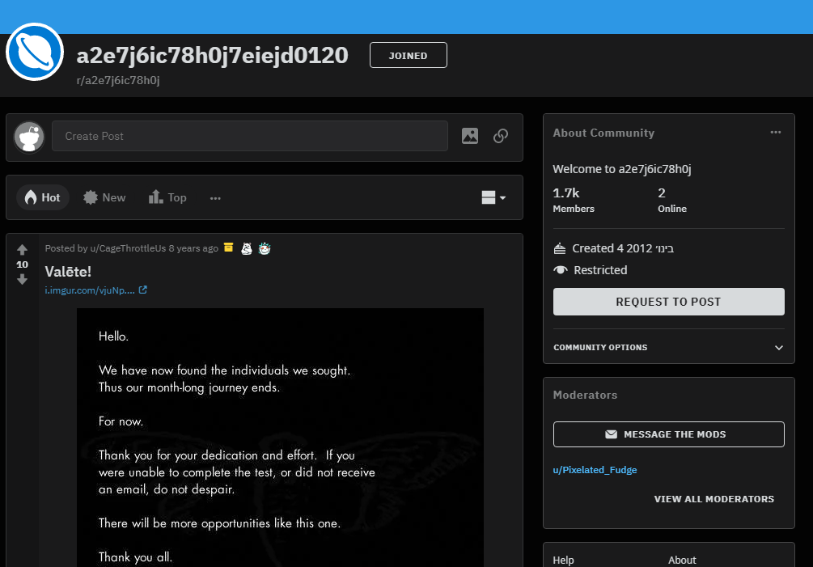The subreddit

The wiki does have that information. But yes, the encrypted posts were lines from the Mabinogion —we were previously given a book code, which when applied to the decrypted mabinogion posts resulted in a phone number to call. Here are the decrypted posts: <https://pastebin.com/iiiAWyNQ>

**The decrypted posts:**

King Arthur was at Caerlleon upon Usk; and one day he sat in his

chamber; and with him were Owain the son of Urien, and Kynon the son

of Clydno, and Kai the son of Kyner; and Gwenhwyvar and her

handmaidens at needlework by the window. And if it should be said

that there was a porter at Arthur's palace, there was none. Glewlwyd

Gavaelvawr was there, acting as porter, to welcome guests and

strangers, and to receive them with honour, and to inform them of the

manners and customs of the Court; and to direct those who came to the

Hall or to the presence-chamber, and those who came to take up their lodging.

In the centre of the chamber King Arthur sat upon a seat of green

rushes, over which was spread a covering of flame-coloured satin, and

a cushion of red satin was under his elbow.

Then Arthur spoke, "If I thought you would not disparage me," said

he, "I would sleep while I wait for my repast; and you can entertain

one another with relating tales, and can obtain a flagon of mead and

some meat from Kai." And the King went to sleep. And Kynon the son

of Clydno asked Kai for that which Arthur had promised them. "I,

too, will have the good tale which he promised to me," said Kai.

"Nay," answered Kynon, "fairer will it be for thee to fulfill

Arthur's behest, in the first place, and then we will tell thee the

best tale that we know." So Kai went to the kitchen and to the mead-

cellar, and returned bearing a flagon of mead and a golden goblet,

and a handful of skewers, upon which were broiled collops of meat.

Then they ate the collops and began to drink the mead. "Now," said

Kai, "it is time for you to give me my story." "Kynon," said Owain,

"do thou pay to Kai the tale that is his due." "Truly," said Kynon,

"thou are older, and art a better teller of tales, and hast seen more

marvellous things than I; do thou therefore pay Kai his tale."

"Begin thyself," quoth Owain, "with the best that thou knowest." "I

will do so," answered Kynon.

"I was the only son of my mother and father, and I was exceedingly

aspiring, and my daring was very great. I thought there was no

enterprise in the world too mighty for me, and after I had achieved

all the adventures that were in my own country, I equipped myself,

and set forth to journey through deserts and distant regions. And at

length it chanced that I came to the fairest valley in the world,

wherein were trees of equal growth; and a river ran through the

valley, and a path was by the side of the river. And I followed the

path until mid-day, and continued my journey along the remainder of

the valley until the evening; and at the extremity of a plain I came

to a large and lustrous Castle, at the foot of which was a torrent.

And I approached the Castle, and there I beheld two youths with

yellow curling hair, each with a frontlet of gold upon his head, and

clad in a garment of yellow satin, and they had gold clasps upon

their insteps. In the hand of each of them was an ivory bow, strung

with the sinews of the stag; and their arrows had shafts of the bone

of the whale, and were winged with peacock's feathers; the shafts

also had golden heads. And they had daggers with blades of gold, and

with hilts of the bone of the whale. And they were shooting their daggers.

"And a little way from them I saw a man in the prime of life, with

his beard newly shorn, clad in a robe and a mantle of yellow satin;

and round the top of his mantle was a band of gold lace. On his feet

were shoes of variegated leather, fastened by two bosses of gold.

When I saw him, I went towards him and saluted him, and such was his

courtesy that he no sooner received my greeting than he returned it.

And he went with me towards the Castle. Now there were no dwellers

in the Castle except those who were in one hall. And there I saw

four-and-twenty damsels, embroidering satin at a window. And this I

tell thee, Kai, that the least fair of them was fairer than the

fairest maid thou hast ever beheld in the Island of Britain, and the

least lovely of them was more lovely than Gwenhwyvar, the wife of

Arthur, when she has appeared loveliest at the Offering, on the day

of the Nativity, or at the feast of Easter. They rose up at my

coming, and six of them took my horse, and divested me of my armour;

and six others took my arms, and washed them in a vessel until they

were perfectly bright. And the third six spread cloths upon the

tables and prepared meat. And the fourth six took off my soiled

garments, and placed others upon me; namely, an under-vest and a

doublet of fine linen, and a robe, and a surcoat, and a mantle of